Tyson Mohanna
14/06/2026
Contents
Introduction 1
PowerShell encoded command execution 1
User Creation 3
Technical Summary 5
Management Summary 6

Introduction
This investigation focuses on identifying a suspected backdoor within the environment, including how it was created, the timeline of its execution, the actors involved, and the hosts that were potentially compromised. The analysis aims to determine the origin of the malicious activity, the methods used to establish persistence, and the extent of lateral movement across affected systems.

PowerShell encoded command execution
The investigation began with the identification of a suspicious PowerShell execution event from the user James.browne. Analysis of the command line revealed that PowerShell was launched using a Base64-encoded command through the -enc parameter. This technique is commonly used to conceal the contents of a script and hinder detection by security monitoring tools.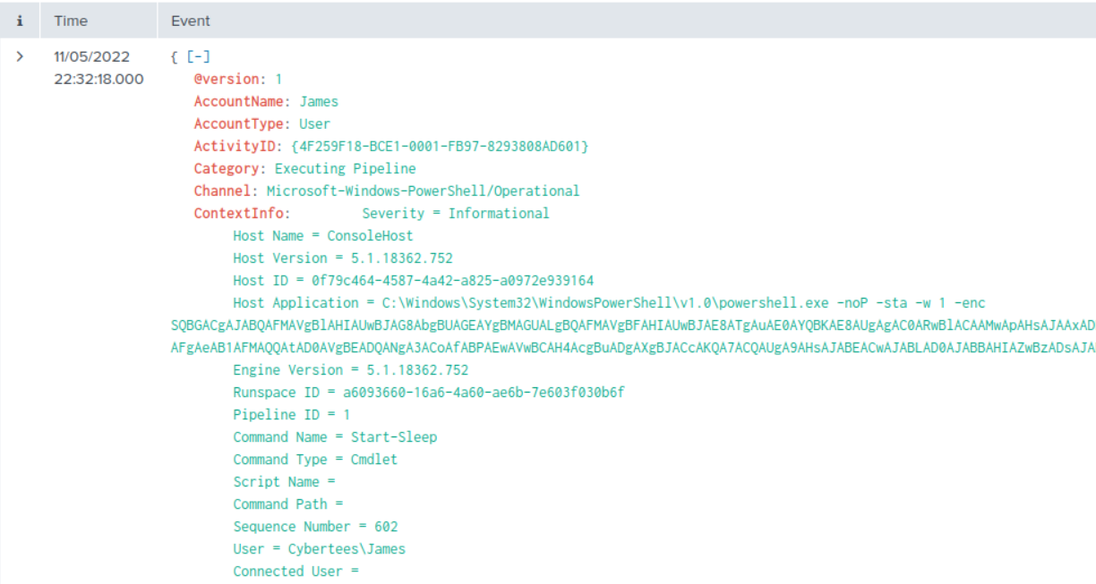
Looking at the decoded version, we can see that the command references another encoded string and instructs the system to download a PHP file called /news.php.
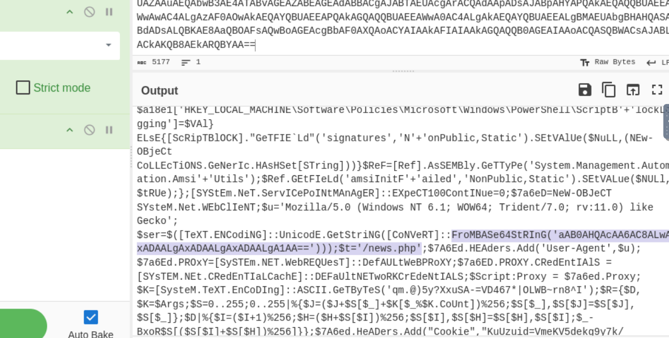
After decoding the command, we identify the full malicious address from which the PHP file is being downloaded: http://10.10.10.5/news.php.
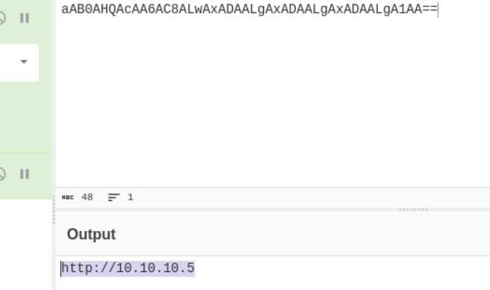
The command uses obfuscation and AMSI bypass techniques to evade detection by security tools. It breaks up key strings (such as AmsiUtils and amsiInitFailed) and reconstructs them at runtime, making static analysis harder. It then directly modifies the AMSI configuration in memory to disable script scanning, allowing malicious PowerShell code to execute without being inspected by Windows Defender.

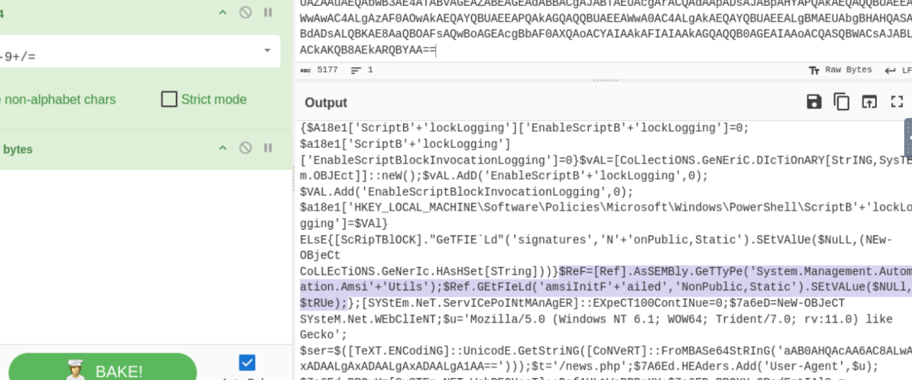

The script uses IEX (Invoke-Expression) to execute dynamically generated or downloaded content directly in memory. After retrieving and decrypting the payload, the code is reconstructed into a readable PowerShell command and immediately executed without being written to disk. This technique is commonly used in fileless attacks to run malicious code while avoiding traditional file-based detection methods.
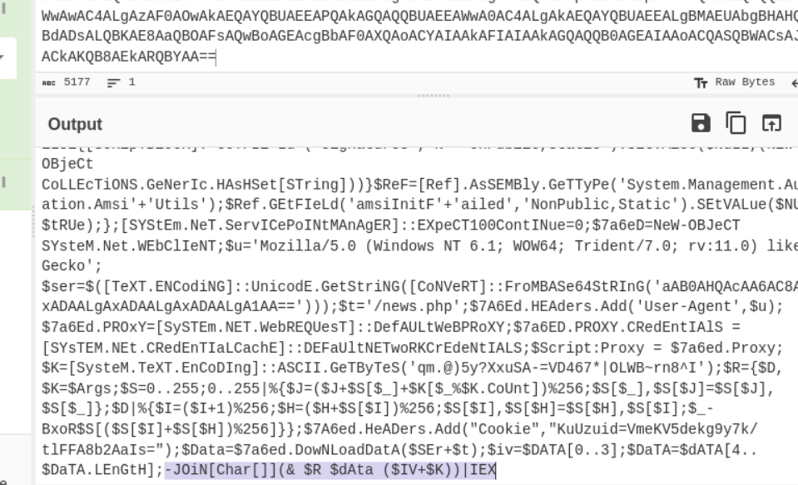

User Creation
We further investigated the suspicious activity associated with the user on the host James.browne by filtering logs using Event ID 4688 (Process Creation). By analysing the CommandLine field, we identified a notable command indicative of remote code execution, which was used to create a new user account named A1berto on a remote machine. The command shows PowerShell being used to invoke WMIC, which then executes a remote process creation call. This results in the execution of net user /add on the target system, confirming remote administrative activity being performed from the originating host.
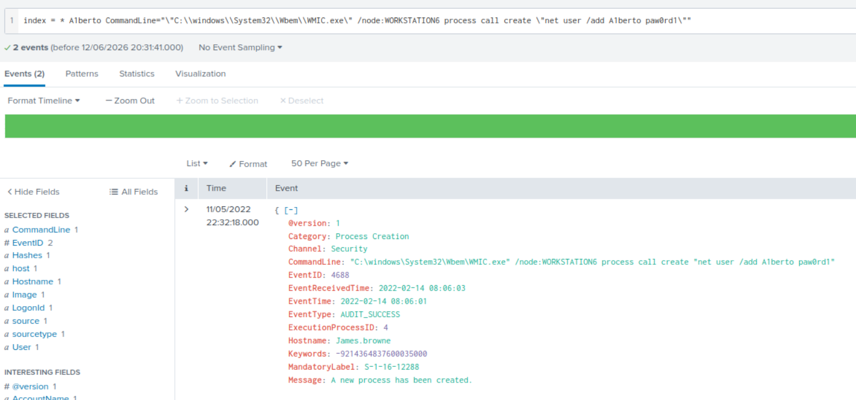

After that, by filtering on Event ID 4720, we can identify the user account that was created because of the activity initiated from James.browne. This event confirms the creation of the new user account A1berto and shows that the action was executed on behalf of the user Micheal.Beaven.
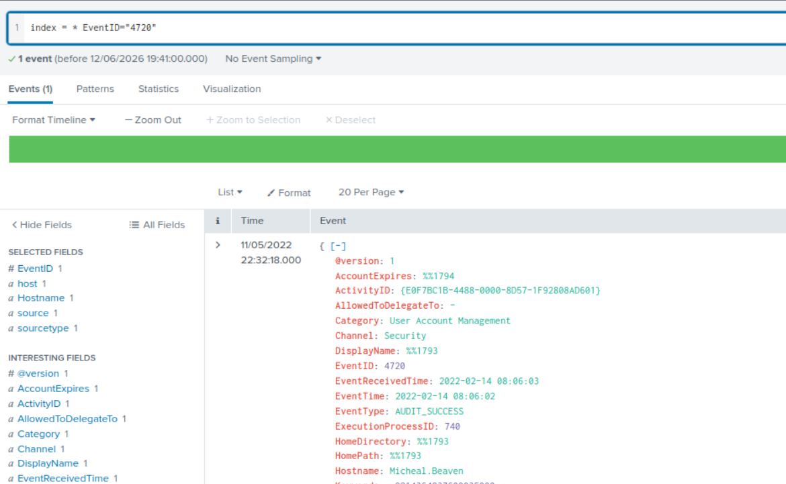

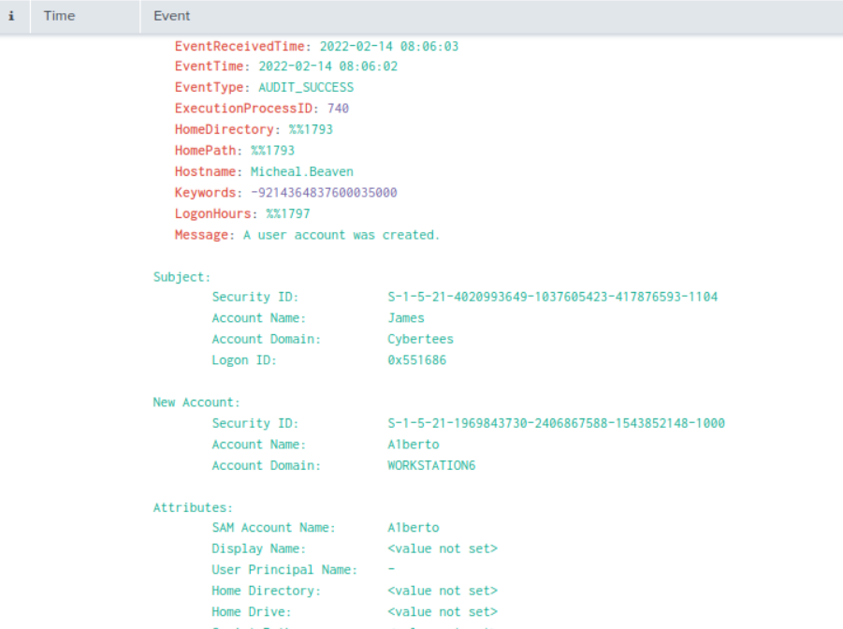

Technical Summary
The investigation identified a multi-stage attack involving malicious PowerShell execution on an internal host, resulting in the deployment of a suspected backdoor within the environment. The initial payload was delivered via a Base64-encoded PowerShell command, which decoded into obfuscated instructions designed to bypass security controls such as AMSI and PowerShell logging.
The script established communication with a remote server (http://10.10.10.5/news.php) to retrieve additional payload content, which was executed in memory using Invoke-Expression (IEX), consistent with fileless malware techniques and backdoor deployment behaviour. Further analysis revealed evidence of lateral movement using WMIC, enabling remote command execution on another system within the environment. This activity resulted in the creation of a new local user account (A1berto) on the target machine, indicating persistence associated with the backdoor.
Overall, the evidence confirms initial execution, defence evasion, command-and-control communication, lateral movement, and persistence across multiple systems.

Management Summary
An investigation was conducted into suspicious activity detected within the environment. The analysis confirmed that a malicious script was executed on an internal system, which then connected to an external server to download additional harmful components.
The attacker used stealth techniques to avoid detection and was able to move to another system within the network. As a result, a new unauthorized user account was created on a secondary machine, indicating successful compromise beyond the initial system.
The incident highlights a security breach involving multiple systems and demonstrates the need for improved monitoring and restrictions on script execution and remote administration tools.

